Experiment No. 3
[i] binary :

#include <stdio.h>

int main() {
int arr[100], n, i, key;
int low = 0, high, mid, found = 0;

printf("Enter number of elements: ");
scanf("%d", &n);
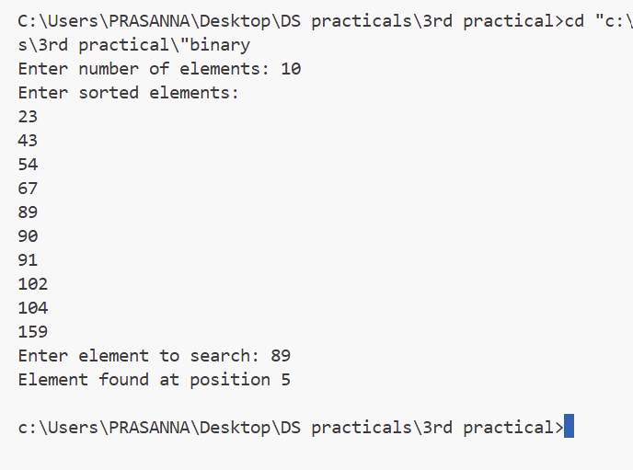
printf("Enter sorted elements:\n");
for(i = 0; i < n; i++) {
scanf("%d", &arr[i]);
}

printf("Enter element to search: ");
scanf("%d", &key);

high = n - 1;

while(low <= high) {
mid = (low + high) / 2;

if(arr[mid] == key) {
printf("Element found at position %d\n", mid + 1);
found = 1;
break;
}
else if(arr[mid] < key)
low = mid + 1;
else
high = mid - 1;
}

if(found == 0)
printf("Element not found\n");

return 0;
}

[ii] Linear :

#include <stdio.h>

int main() {
int arr[100], n, i, key, found = 0;

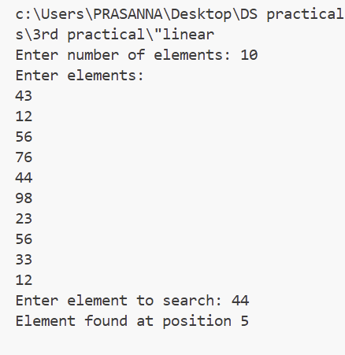
printf("Enter number of elements: ");
scanf("%d", &n);

printf("Enter elements:\n");
for(i = 0; i < n; i++) {
scanf("%d", &arr[i]);
}

printf("Enter element to search: ");
scanf("%d", &key);

for(i = 0; i < n; i++) {
if(arr[i] == key) {
printf("Element found at position %d\n", i + 1);
found = 1;
break;
}
}

if(found == 0)
printf("Element not found\n");

return 0;
}

[iii] : Hashing :
#include<stdio.h>

#define SIZE 7

int hashTable[SIZE];

void initialize()
{
for(int i = 0; i < SIZE; i++)
hashTable[i] = -1; // -1 means empty
}

void insert(int key)
{
int index = key % SIZE;
int start = index;

while(hashTable[index] != -1 && hashTable[index] != -2)
{
index = (index + 1) % SIZE;

if(index == start)
{
printf("Hash Table is Full\n");
return;
}
}

hashTable[index] = key;
printf("Key %d inserted at index %d\n", key, index);
}

void search(int key)
{
int index = key % SIZE;
int start = index;

while(hashTable[index] != -1)
{
if(hashTable[index] == key)
{
printf("Key %d found at index %d\n", key, index);
return;
}

index = (index + 1) % SIZE;

if(index == start)
break;
}

printf("Key not found\n");
}

void deleteKey(int key)
{
int index = key % SIZE;
int start = index;

while(hashTable[index] != -1)
{
if(hashTable[index] == key)
{
hashTable[index] = -2; // -2 means deleted
printf("Key %d deleted\n", key);
return;
}

index = (index + 1) % SIZE;

if(index == start)
break;
}

printf("Key not found\n");
}

void display()
{
printf("\nHash Table:\n");
for(int i = 0; i < SIZE; i++)
{
printf("Index %d : ", i);

if(hashTable[i] == -1)
printf("Empty\n");
else if(hashTable[i] == -2)
printf("Deleted\n");
else
printf("%d\n", hashTable[i]);
}
}

int main()
{
int choice, key;

initialize();

while(1)
{
printf("\n1. Insert\n2. Search\n3. Delete\n4. Display\n5. Exit\n");
printf("Enter choice: ");
scanf("%d", &choice);

switch(choice)
{
case 1:
printf("Enter key to insert: ");
scanf("%d", &key);
insert(key);
break;

case 2:
printf("Enter key to search: ");
scanf("%d", &key);
search(key);
break;

case 3:
printf("Enter key to delete: ");
scanf("%d", &key);
deleteKey(key);
break;

case 4:
display();
break;

case 5:
return 0;

default:
printf("Invalid choice\n");
}
}
}

